USER

GUIDE

Table of Contents

1. Introduction 3

2. Create account 4

3. The main screen 6

4. Add plant 7

5. Edit account 8

6. Edit plant’s profile 9

# Introduction

Welcome to the Smart Garden’s Android application user guide. This guide is designed to provide documentation for those who will use the Smart Garden system to tend to their plant remotely and effortlessly. All users have access to the features described in this guide.

Let’s begin!

# Create account

To launch the app, tap the application icon on the home screen of the Android device.

**Note:** The device must be connected to the Internet.

To create an account the user must click the “Register” button located on the login screen. Then he will be directed to the registration form that requires the new user’s email and chosen password.

**Note:** The password must contain at least 6 characters and have both upper and lower case letters.

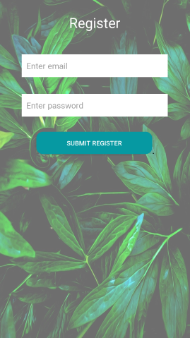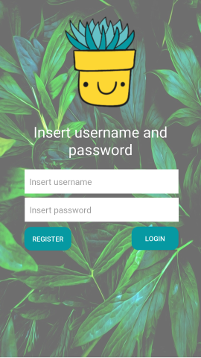

Once the form has been filled, the user has to click the “Submit Register” button and the application will present the main screen.

The next time the user uses the app, he simply needs to input the credentials in the login form, click the “Login button” and the main screen will open up if the inputted information was correct.



# The main screen

The main screen presents the list of plants that the logged in user has. The user can click on the plant’s name to see the current conditions of it, or he can click the pen icon to edit the plants features. It is also possible to delete a plant’s profile.

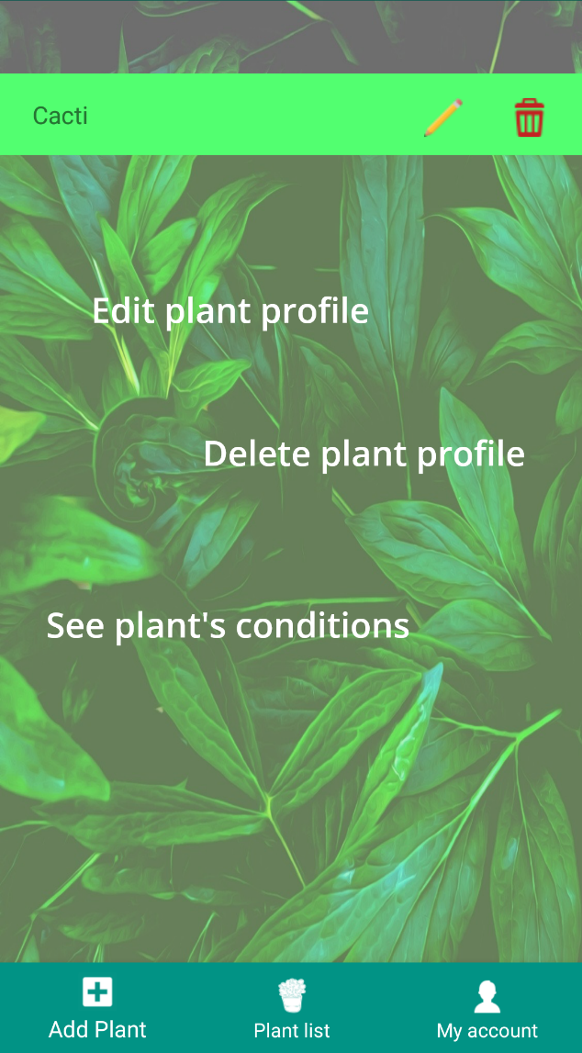

The bottom navigation menu has three items. By clicking the “Add Plant” button to the far left, the user can add a new plant profile to his list of plants.

The “Plant List” button is the default page for the application and the “My Account” button allows the logged in user to change his credentials.



# Add plant

When clicking the “Add plant” button on the bottom navigation bar, the user is directed to a form that allows him to add a new plant to his list of plants. For that he has to input a plant name and choose one of the predefined plant templates.



# Edit account

By clicking the “My account” button on the bottom navigation bar, the user is directed to a form where he can choose another email and/or password for his account. There is also the possibility of deleting the current account by clicking the red icon placed on the bottom right of the screen.

# Edit plant’s profile

By clicking the pen icon next to the plant’s name that appears in the list of plants, the user can modify certain parameters that have been set for that plant.

